**CODING TEST - 1 (SQL)**

VAIBHAV PATIDAR

13/12/2023

Only Queries File : [**CLICK HERE**](https://docs.google.com/document/u/0/d/1RuGL8Ab3fZ8F5qqx57ev_h3lMQ-oWJ0ikFOaTKJCErY/edit)

**Q1. Querying Data by Using Joins and Subqueries.**

**→ Creating a Customer table :**

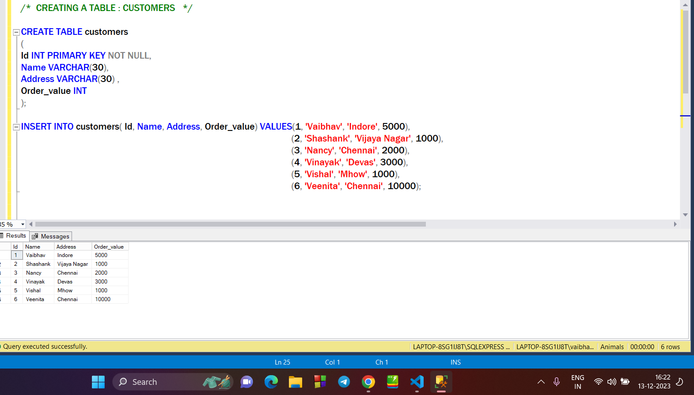

→ **Creating a items table :**

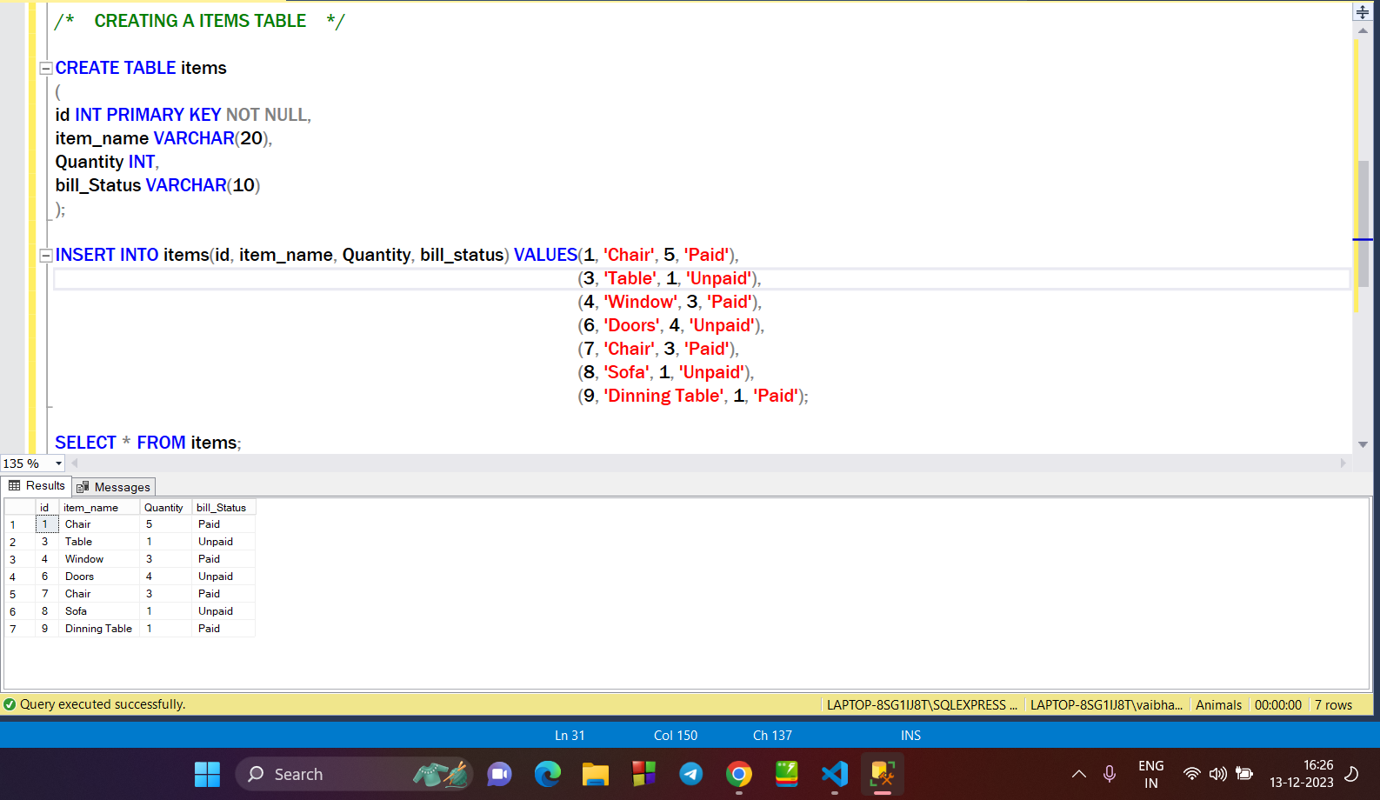

**→ Applying INNER JOIN on customers & items table :**

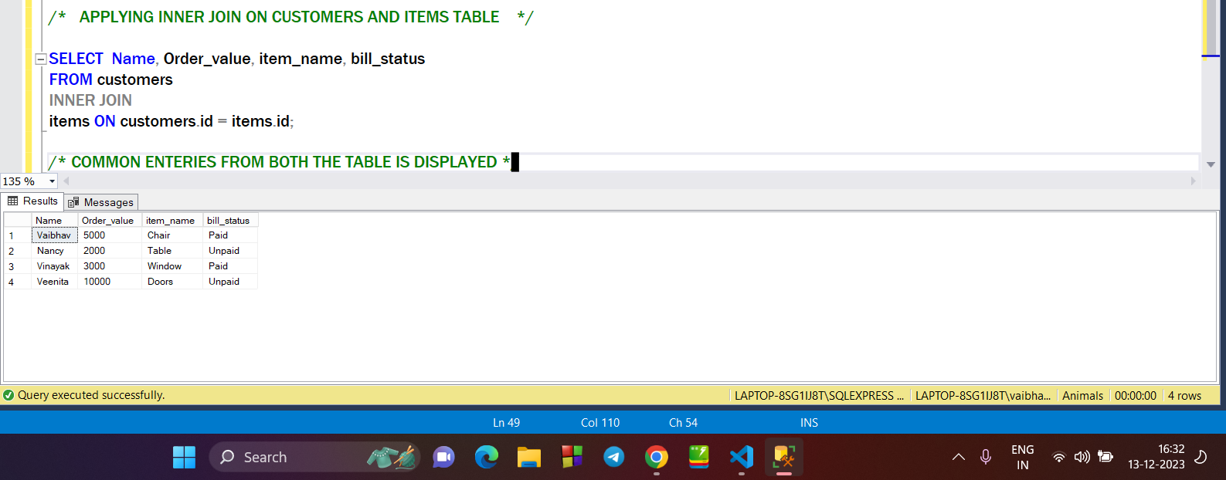

**→ Applying RIGHT JOIN on customers and items table :**

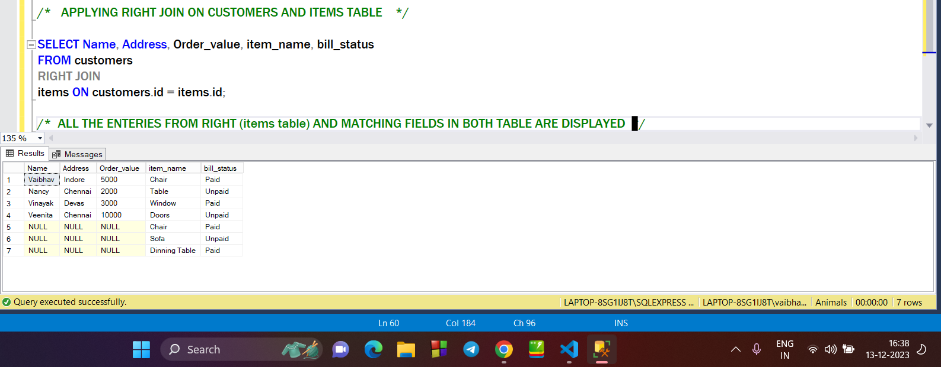

**→ APPLYING LEFT JOIN ON CUSTOMERS & ITEMS TABLE :**

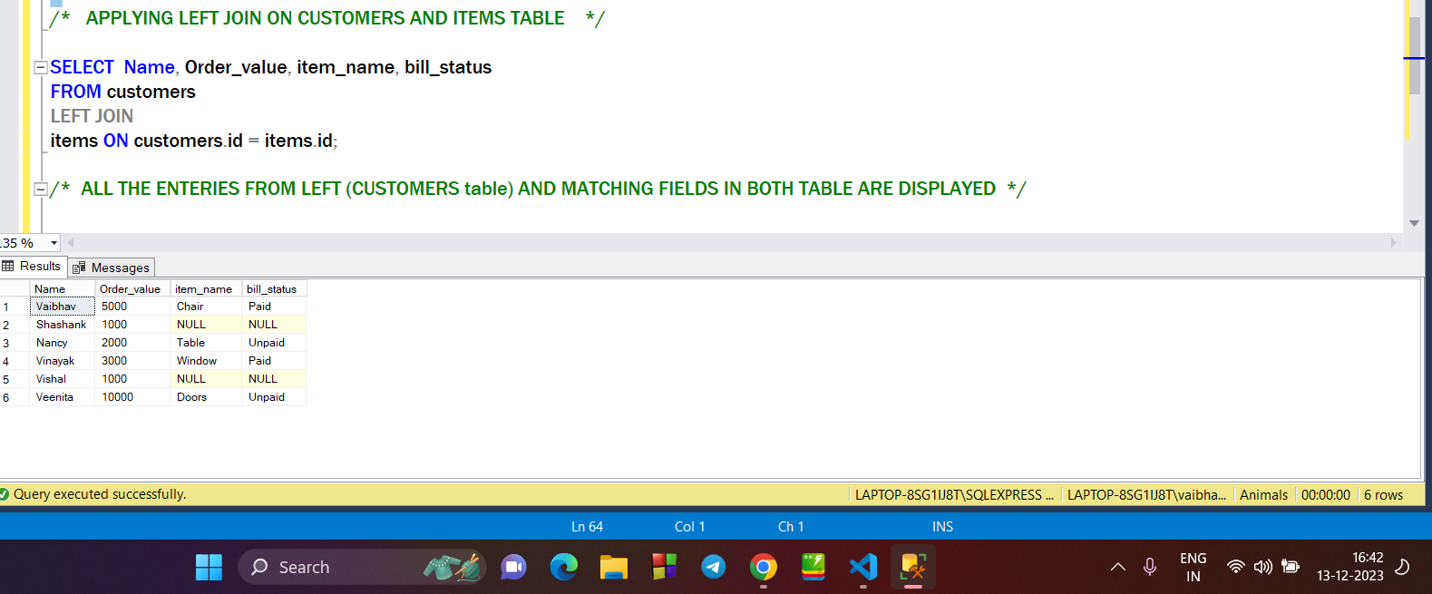

**→ APPLYING FULL OUTER JOIN ON CUSTOMERS AND ITEMS TABLE :**

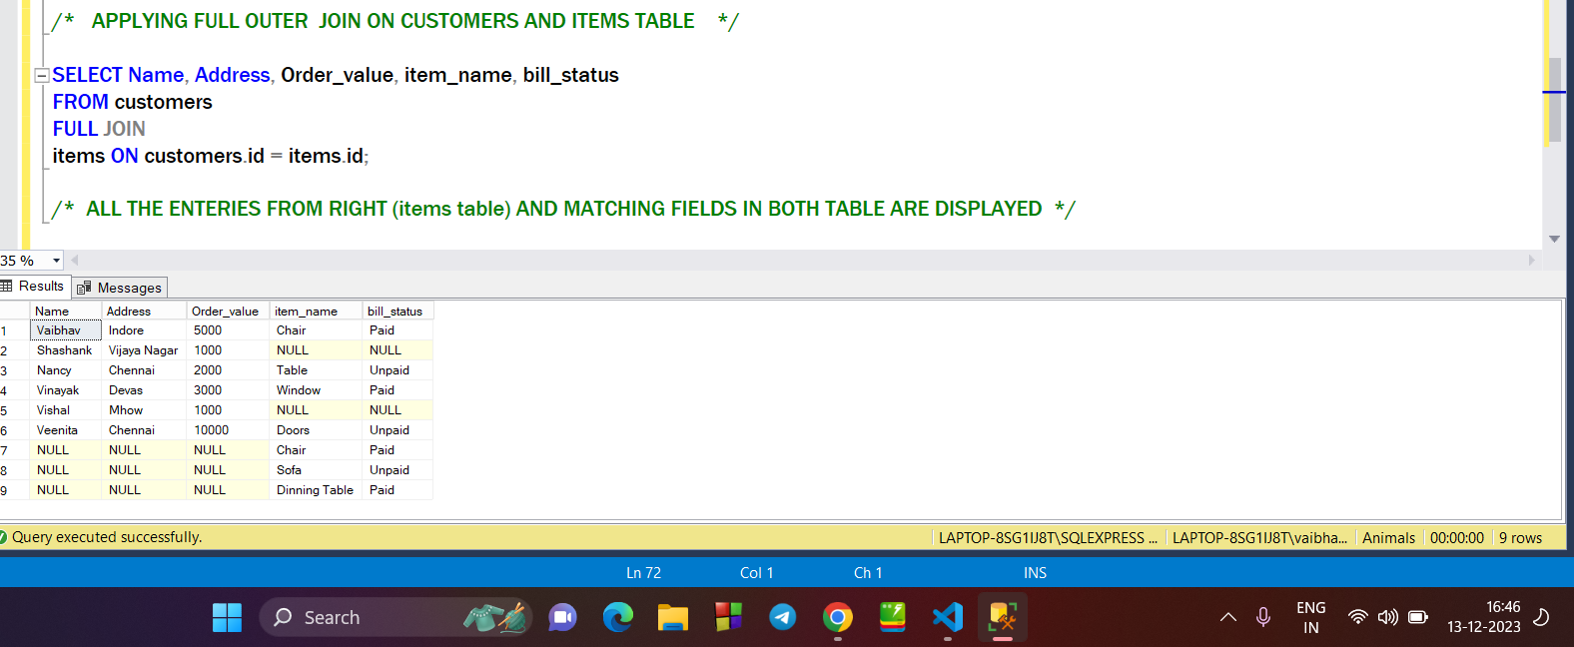

**→ SUB QUERY WITH JOIN :**

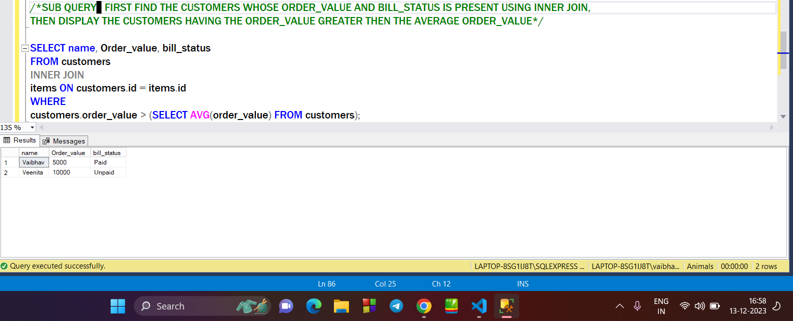

************

**Q2. Manipulate data by using sql commands using groupby and having clause.**

**→ Creating Employee Table and inserting data into it :**

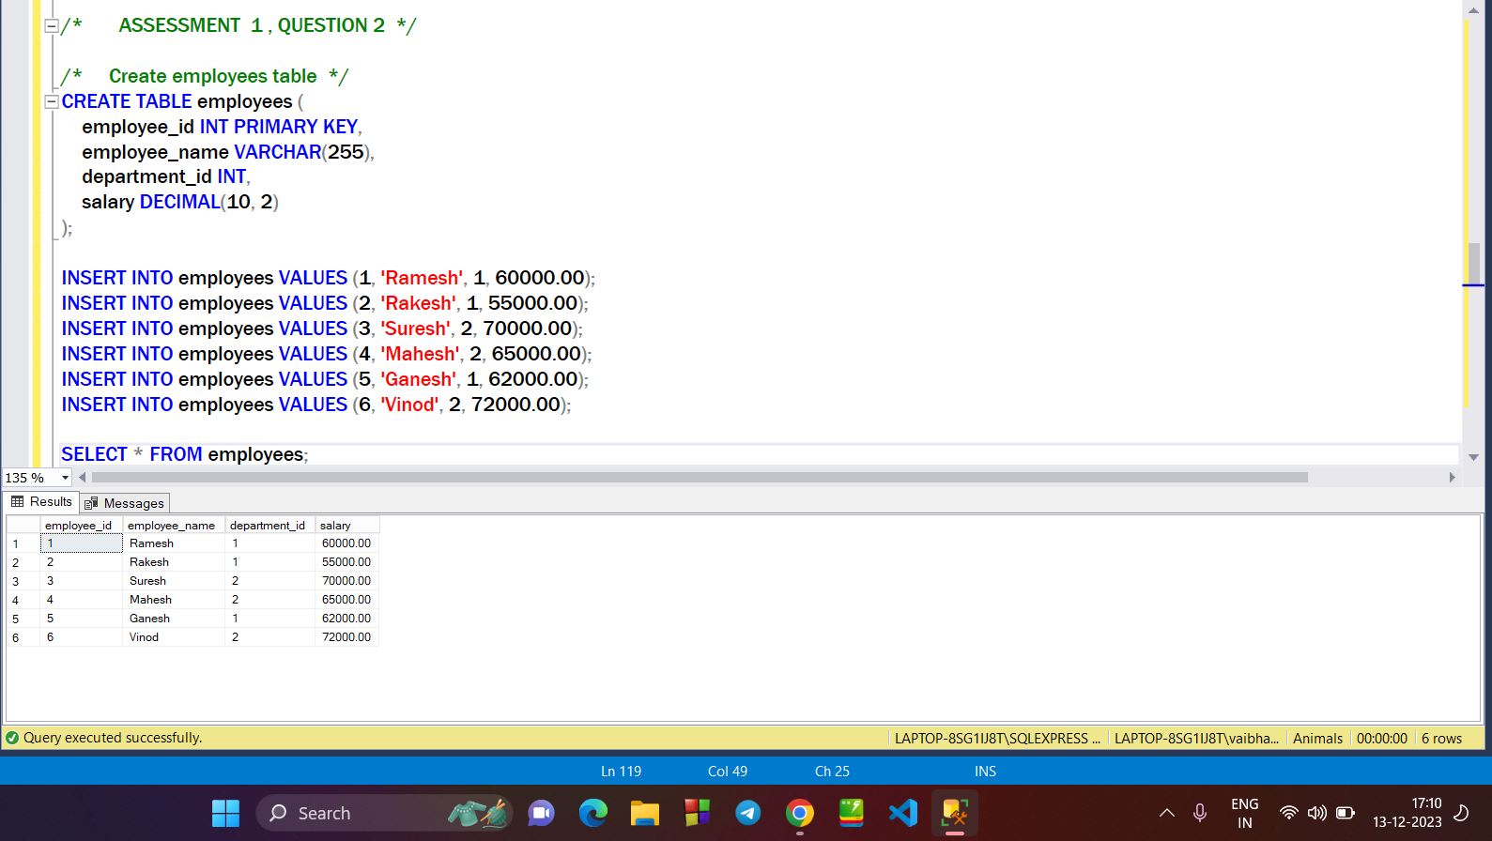

**→ DML COMMAND (UPDATE) : change the salary of Suresh :**

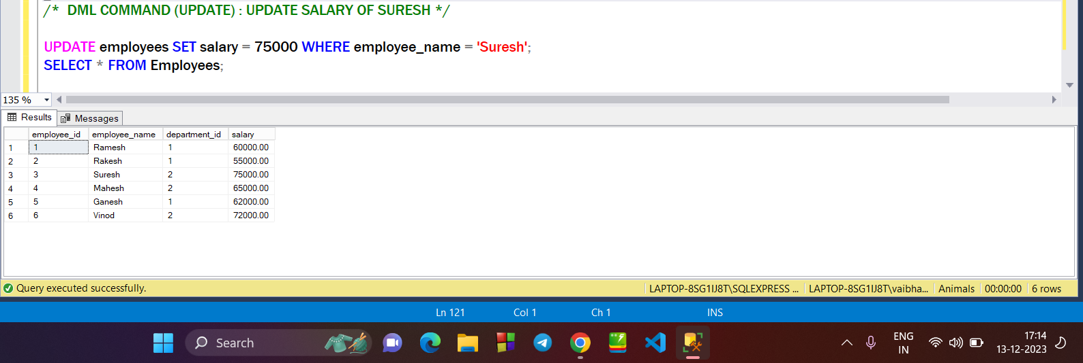

**→ DML COMMAND (DELETE) : Adding a duplicate value and deleting it from the table:**

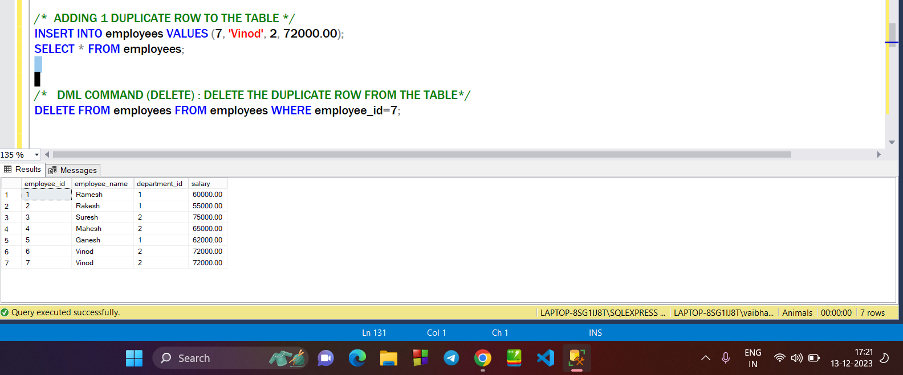

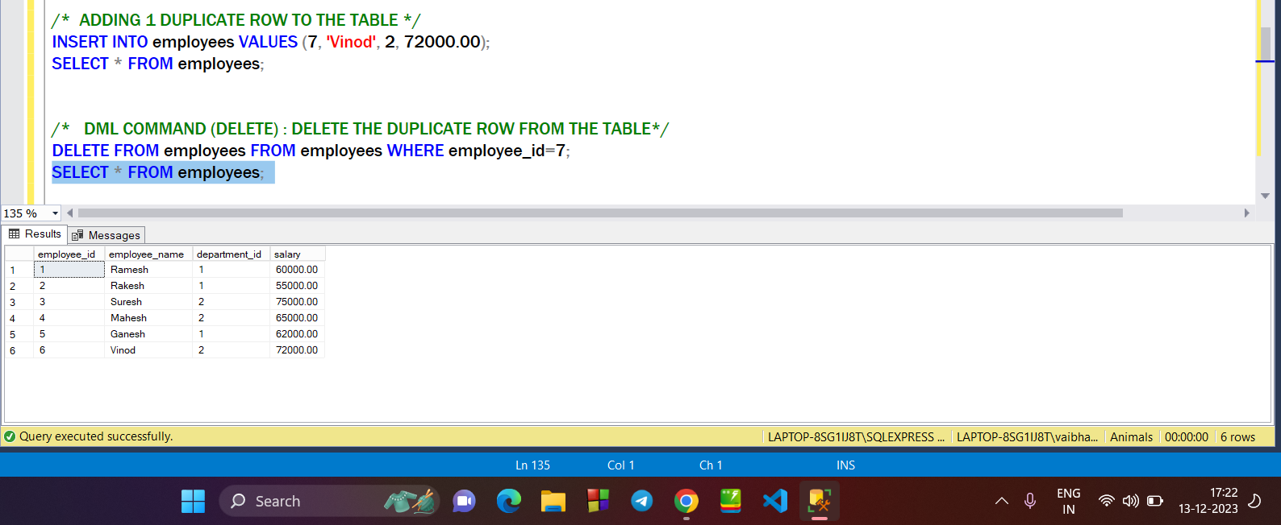

**→ Using *GROUP_BY* Clause to find the *Average salary* based on department id :** 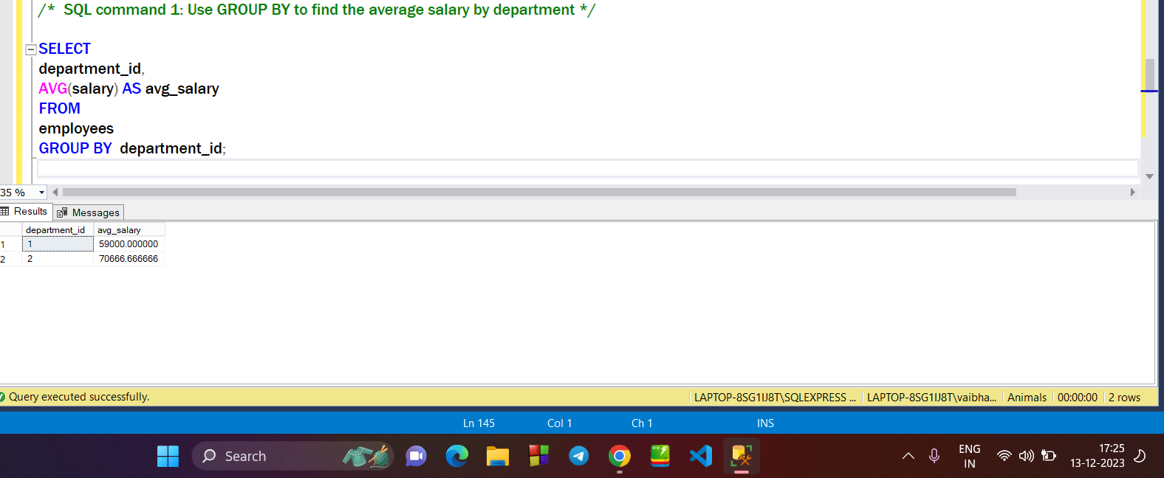

**→ Using *GROUP_BY & HAVING* Clause to find the *departments HAVING more then 1 employee* :**

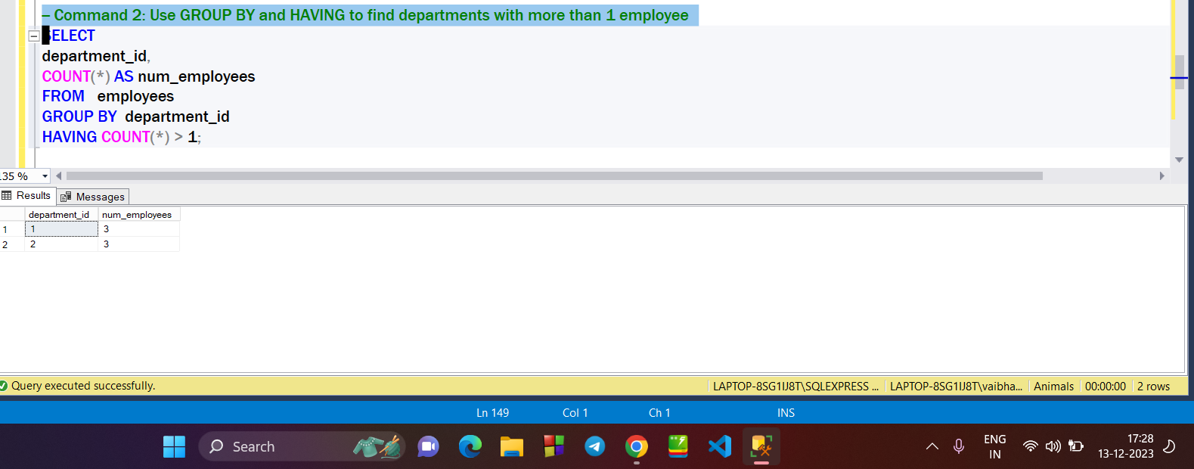

**→ Find the department_id of departments having average salary greater then the overall average salary :**

